[](https://ida.interchain.io/)

[Interchain Developer Academy](https://ida.interchain.io/)/[Interchain Developer Academy](https://ida.interchain.io/academy/1-what-is-cosmos/3-atom-staking.html)



Search

[Interchain Developer Academy](https://ida.interchain.io/)[Interchain Developer Academy](https://ida.interchain.io/academy/1-what-is-cosmos/3-atom-staking.html)

Search



Filters

Interchain Developer Academy

[](https://ida.interchain.io/academy/1-what-is-cosmos/3-atom-staking.html)

[Week 0 - Getting Started](https://ida.interchain.io/academy/1-what-is-cosmos/3-atom-staking.html)

[Getting Started](https://ida.interchain.io/academy/1-what-is-cosmos/3-atom-staking.html)

[Blockchain 101](https://ida.interchain.io/academy/1-what-is-cosmos/3-atom-staking.html)

[Blockchain History](https://ida.interchain.io/academy/1-what-is-cosmos/3-atom-staking.html)

[Public and Managed Blockchains](https://ida.interchain.io/academy/1-what-is-cosmos/3-atom-staking.html)

[Consensus in Distributed Networks](https://ida.interchain.io/academy/1-what-is-cosmos/3-atom-staking.html)

[Cryptography](https://ida.interchain.io/academy/1-what-is-cosmos/3-atom-staking.html)

[Self-Assessment Quiz](https://ida.interchain.io/academy/1-what-is-cosmos/3-atom-staking.html)

[Go Introduction - First Steps](https://ida.interchain.io/academy/1-what-is-cosmos/3-atom-staking.html)

[Go Basics](https://ida.interchain.io/academy/1-what-is-cosmos/3-atom-staking.html)

[Go Interfaces](https://ida.interchain.io/academy/1-what-is-cosmos/3-atom-staking.html)

[Control Structures in Go](https://ida.interchain.io/academy/1-what-is-cosmos/3-atom-staking.html)

[Arrays and Slices in Go](https://ida.interchain.io/academy/1-what-is-cosmos/3-atom-staking.html)

[Standard Packages in Go](https://ida.interchain.io/academy/1-what-is-cosmos/3-atom-staking.html)

[Concurrency in Go](https://ida.interchain.io/academy/1-what-is-cosmos/3-atom-staking.html)

[Good-To-Know Dev Terms](https://ida.interchain.io/academy/1-what-is-cosmos/3-atom-staking.html)

[Docker Introduction](https://ida.interchain.io/academy/1-what-is-cosmos/3-atom-staking.html)

[](https://ida.interchain.io/academy/1-what-is-cosmos/3-atom-staking.html)

[Week 1 - Introduction to the Interchain](https://ida.interchain.io/academy/1-what-is-cosmos/3-atom-staking.html)

[Introduction to the Interchain](https://ida.interchain.io/academy/1-what-is-cosmos/3-atom-staking.html)

[Blockchain Technology and the Interchain](https://ida.interchain.io/academy/1-what-is-cosmos/3-atom-staking.html)

[The Interchain Ecosystem](https://ida.interchain.io/academy/1-what-is-cosmos/3-atom-staking.html)

[Getting ATOM and Staking It](https://ida.interchain.io/academy/1-what-is-cosmos/3-atom-staking.html)

[A Blockchain App Architecture](https://ida.interchain.io/academy/1-what-is-cosmos/3-atom-staking.html)

[Accounts](https://ida.interchain.io/academy/1-what-is-cosmos/3-atom-staking.html)

[Transactions](https://ida.interchain.io/academy/1-what-is-cosmos/3-atom-staking.html)

[Messages](https://ida.interchain.io/academy/1-what-is-cosmos/3-atom-staking.html)

[Modules](https://ida.interchain.io/academy/1-what-is-cosmos/3-atom-staking.html)

[Protobuf](https://ida.interchain.io/academy/1-what-is-cosmos/3-atom-staking.html)

[Multistore and Keepers](https://ida.interchain.io/academy/1-what-is-cosmos/3-atom-staking.html)

[BaseApp](https://ida.interchain.io/academy/1-what-is-cosmos/3-atom-staking.html)

[Queries](https://ida.interchain.io/academy/1-what-is-cosmos/3-atom-staking.html)

[Events](https://ida.interchain.io/academy/1-what-is-cosmos/3-atom-staking.html)

[Context](https://ida.interchain.io/academy/1-what-is-cosmos/3-atom-staking.html)

[Testing](https://ida.interchain.io/academy/1-what-is-cosmos/3-atom-staking.html)

[Relaying with IBC](https://ida.interchain.io/academy/1-what-is-cosmos/3-atom-staking.html)

[Interchain Security](https://ida.interchain.io/academy/1-what-is-cosmos/3-atom-staking.html)

[Bridges](https://ida.interchain.io/academy/1-what-is-cosmos/3-atom-staking.html)

[Migrations](https://ida.interchain.io/academy/1-what-is-cosmos/3-atom-staking.html)

[Week 1 Quiz](https://ida.interchain.io/academy/1-what-is-cosmos/3-atom-staking.html)

[](https://ida.interchain.io/academy/1-what-is-cosmos/3-atom-staking.html)

[Week 2 - First Steps](https://ida.interchain.io/academy/1-what-is-cosmos/3-atom-staking.html)

[First Steps](https://ida.interchain.io/academy/1-what-is-cosmos/3-atom-staking.html)

[Setup Your Work Environment](https://ida.interchain.io/academy/1-what-is-cosmos/3-atom-staking.html)

[Run a Node, API, and CLI](https://ida.interchain.io/academy/1-what-is-cosmos/3-atom-staking.html)

[Ignite CLI](https://ida.interchain.io/academy/1-what-is-cosmos/3-atom-staking.html)

[Exercise - Make a Checkers Blockchain](https://ida.interchain.io/academy/1-what-is-cosmos/3-atom-staking.html)

[Store Object](https://ida.interchain.io/academy/1-what-is-cosmos/3-atom-staking.html)

[Create Custom Messages](https://ida.interchain.io/academy/1-what-is-cosmos/3-atom-staking.html)

[Create and Save a Game Properly](https://ida.interchain.io/academy/1-what-is-cosmos/3-atom-staking.html)

[Add a Way to Make a Move](https://ida.interchain.io/academy/1-what-is-cosmos/3-atom-staking.html)

[Emit Game Information](https://ida.interchain.io/academy/1-what-is-cosmos/3-atom-staking.html)

[Record the Game Winner](https://ida.interchain.io/academy/1-what-is-cosmos/3-atom-staking.html)

[Week 2 Exercise](https://ida.interchain.io/academy/1-what-is-cosmos/3-atom-staking.html)

[](https://ida.interchain.io/academy/1-what-is-cosmos/3-atom-staking.html)

[Week 3 - Introduction to IBC and CosmJS](https://ida.interchain.io/academy/1-what-is-cosmos/3-atom-staking.html)

[Introduction to IBC and CosmJS](https://ida.interchain.io/academy/1-what-is-cosmos/3-atom-staking.html)

[What is IBC?](https://ida.interchain.io/academy/1-what-is-cosmos/3-atom-staking.html)

[IBC/TAO - Connections (OPTIONAL)](https://ida.interchain.io/academy/1-what-is-cosmos/3-atom-staking.html)

[IBC/TAO - Channels (OPTIONAL)](https://ida.interchain.io/academy/1-what-is-cosmos/3-atom-staking.html)

[IBC/TAO - Clients (OPTIONAL)](https://ida.interchain.io/academy/1-what-is-cosmos/3-atom-staking.html)

[IBC Token Transfer](https://ida.interchain.io/academy/1-what-is-cosmos/3-atom-staking.html)

[Interchain Accounts (OPTIONAL)](https://ida.interchain.io/academy/1-what-is-cosmos/3-atom-staking.html)

[IBC Middleware (OPTIONAL)](https://ida.interchain.io/academy/1-what-is-cosmos/3-atom-staking.html)

[Create a Custom IBC Middleware (OPTIONAL)](https://ida.interchain.io/academy/1-what-is-cosmos/3-atom-staking.html)

[Integrate IBC Middleware Into a Chain (OPTIONAL)](https://ida.interchain.io/academy/1-what-is-cosmos/3-atom-staking.html)

[IBC Tooling](https://ida.interchain.io/academy/1-what-is-cosmos/3-atom-staking.html)

[What is CosmJS?](https://ida.interchain.io/academy/1-what-is-cosmos/3-atom-staking.html)

[Your First CosmJS Actions](https://ida.interchain.io/academy/1-what-is-cosmos/3-atom-staking.html)

[Compose Complex Transactions](https://ida.interchain.io/academy/1-what-is-cosmos/3-atom-staking.html)

[Learn to Integrate Keplr](https://ida.interchain.io/academy/1-what-is-cosmos/3-atom-staking.html)

[Create Custom CosmJS Interfaces](https://ida.interchain.io/academy/1-what-is-cosmos/3-atom-staking.html)

[](https://ida.interchain.io/academy/1-what-is-cosmos/3-atom-staking.html)

[Week 4 - Ignite CLI and IBC Advanced](https://ida.interchain.io/academy/1-what-is-cosmos/3-atom-staking.html)

[Ignite CLI and IBC Advanced](https://ida.interchain.io/academy/1-what-is-cosmos/3-atom-staking.html)

[Keep an Up-To-Date Game Deadline](https://ida.interchain.io/academy/1-what-is-cosmos/3-atom-staking.html)

[Keep Track Of How Many Moves Have Been Played](https://ida.interchain.io/academy/1-what-is-cosmos/3-atom-staking.html)

[Put Your Games in Order](https://ida.interchain.io/academy/1-what-is-cosmos/3-atom-staking.html)

[Auto-Expiring Games](https://ida.interchain.io/academy/1-what-is-cosmos/3-atom-staking.html)

[Let Players Set a Wager](https://ida.interchain.io/academy/1-what-is-cosmos/3-atom-staking.html)

[Handle wager payments](https://ida.interchain.io/academy/1-what-is-cosmos/3-atom-staking.html)

[Integration tests](https://ida.interchain.io/academy/1-what-is-cosmos/3-atom-staking.html)

[Incentivize Players](https://ida.interchain.io/academy/1-what-is-cosmos/3-atom-staking.html)

[Help Find a Correct Move](https://ida.interchain.io/academy/1-what-is-cosmos/3-atom-staking.html)

[Play With Cross-Chain Tokens](https://ida.interchain.io/academy/1-what-is-cosmos/3-atom-staking.html)

[Understand IBC Denoms](https://ida.interchain.io/academy/1-what-is-cosmos/3-atom-staking.html)

[Go Relayer](https://ida.interchain.io/academy/1-what-is-cosmos/3-atom-staking.html)

[Hermes Relayer](https://ida.interchain.io/academy/1-what-is-cosmos/3-atom-staking.html)

[](https://ida.interchain.io/academy/1-what-is-cosmos/3-atom-staking.html)

[Week 5 - CosmJS Advanced](https://ida.interchain.io/academy/1-what-is-cosmos/3-atom-staking.html)

[CosmJS Advanced](https://ida.interchain.io/academy/1-what-is-cosmos/3-atom-staking.html)

[Create Custom Objects](https://ida.interchain.io/academy/1-what-is-cosmos/3-atom-staking.html)

[Create Custom Messages](https://ida.interchain.io/academy/1-what-is-cosmos/3-atom-staking.html)

[Get an External GUI](https://ida.interchain.io/academy/1-what-is-cosmos/3-atom-staking.html)

[Integrate CosmJS and Keplr](https://ida.interchain.io/academy/1-what-is-cosmos/3-atom-staking.html)

[Backend Script for Game Indexing](https://ida.interchain.io/academy/1-what-is-cosmos/3-atom-staking.html)

[](https://ida.interchain.io/academy/1-what-is-cosmos/3-atom-staking.html)

[Week 6 - IBC Deep Dive](https://ida.interchain.io/academy/1-what-is-cosmos/3-atom-staking.html)

[IBC Deep Dive](https://ida.interchain.io/academy/1-what-is-cosmos/3-atom-staking.html)

[IBC Application Developer Introduction](https://ida.interchain.io/academy/1-what-is-cosmos/3-atom-staking.html)

[Make a Module IBC-Enabled](https://ida.interchain.io/academy/1-what-is-cosmos/3-atom-staking.html)

[Adding Packet and Acknowledgment Data](https://ida.interchain.io/academy/1-what-is-cosmos/3-atom-staking.html)

[Extend the Checkers Game With a Leaderboard](https://ida.interchain.io/academy/1-what-is-cosmos/3-atom-staking.html)

[Create a Leaderboard Chain](https://ida.interchain.io/academy/1-what-is-cosmos/3-atom-staking.html)

[](https://ida.interchain.io/academy/1-what-is-cosmos/3-atom-staking.html)

[Week 7 - From Code to MVP to Production and Migrations](https://ida.interchain.io/academy/1-what-is-cosmos/3-atom-staking.html)

[From Code to MVP to Production and Migrations](https://ida.interchain.io/academy/1-what-is-cosmos/3-atom-staking.html)

[Run in Production](https://ida.interchain.io/academy/1-what-is-cosmos/3-atom-staking.html)

[Prepare the Software to Run](https://ida.interchain.io/academy/1-what-is-cosmos/3-atom-staking.html)

[Prepare a Validator and Keys](https://ida.interchain.io/academy/1-what-is-cosmos/3-atom-staking.html)

[Prepare Where the Node Starts](https://ida.interchain.io/academy/1-what-is-cosmos/3-atom-staking.html)

[Prepare and Connect to Other Nodes](https://ida.interchain.io/academy/1-what-is-cosmos/3-atom-staking.html)

[Configure, Run, and Set Up a Service](https://ida.interchain.io/academy/1-what-is-cosmos/3-atom-staking.html)

[Prepare and Do Migrations](https://ida.interchain.io/academy/1-what-is-cosmos/3-atom-staking.html)

[Simulate Production in Docker](https://ida.interchain.io/academy/1-what-is-cosmos/3-atom-staking.html)

[Tally Player Info After Production](https://ida.interchain.io/academy/1-what-is-cosmos/3-atom-staking.html)

[Add a Leaderboard as a Module](https://ida.interchain.io/academy/1-what-is-cosmos/3-atom-staking.html)

[Migrate the Leaderboard Module After Production](https://ida.interchain.io/academy/1-what-is-cosmos/3-atom-staking.html)

[Simulate a Migration in Docker](https://ida.interchain.io/academy/1-what-is-cosmos/3-atom-staking.html)

[Final Exam](https://ida.interchain.io/academy/1-what-is-cosmos/3-atom-staking.html)

[](https://ida.interchain.io/academy/1-what-is-cosmos/3-atom-staking.html)

[What's Next?](https://ida.interchain.io/academy/1-what-is-cosmos/3-atom-staking.html)

[Continue Your Interchain Journey](https://ida.interchain.io/academy/1-what-is-cosmos/3-atom-staking.html)

Docs Version Switcher

On this page

[Setting up Keplr](https://ida.interchain.io/academy/1-what-is-cosmos/3-atom-staking.html#setting-up-keplr)

[Purchase one ATOM](https://ida.interchain.io/academy/1-what-is-cosmos/3-atom-staking.html#purchase-one-atom)

[Withdraw your ATOM](https://ida.interchain.io/academy/1-what-is-cosmos/3-atom-staking.html#withdraw-your-atom)

[Stake your ATOM](https://ida.interchain.io/academy/1-what-is-cosmos/3-atom-staking.html#stake-your-atom)

[Claim your ATOM](https://ida.interchain.io/academy/1-what-is-cosmos/3-atom-staking.html#claim-your-atom)

[#Copy link](https://ida.interchain.io/academy/1-what-is-cosmos/3-atom-staking.html#getting-atom-and-staking-it) **Getting ATOM and Staking It**



In this section you are going to:

* Get some ATOM.
* Participate in the consensus, to passively earn a yield on your ATOMs while working on your own Cosmos application, sleeping, or studying further.

The [Cosmos Hub (opens new window)↗](https://hub.cosmos.network/) is the first among equals of Cosmos blockchains. ATOM is its native token, also called the staking token. You need some ATOM to be able to transact on the Cosmos Hub or to participate in the proof-of-stake (PoS) consensus.



The main concepts are covered in more detail in the [next chapter](https://ida.interchain.io/academy/2-cosmos-concepts/).

There are two steps to successfully get ATOM:

1. Install a wallet application and configure it safely. You will use [Keplr (opens new window)↗](https://keplr.app/).
2. Buy some ATOM on an exchange and transfer them to your wallet.

If you prefer to do the same but with test ATOMs, you can use an existing Cosmos Hub testnet. Head to this [later section](https://ida.interchain.io/tutorials/7-cosmjs/2-first-steps.html#get-a-balance) for guidance. Then come back here and adjust accordingly for the relevant testnet.

[#Copy link](https://ida.interchain.io/academy/1-what-is-cosmos/3-atom-staking.html#setting-up-keplr) Setting up Keplr

Open Google Chrome on your computer and go to the [Keplr extension page (opens new window)↗](https://chrome.google.com/webstore/detail/keplr/dmkamcknogkgcdfhhbddcghachkejeap). Alternatively, you can search for Keplr in the [Chrome extensions store (opens new window)↗](https://chrome.google.com/webstore/search/Keplr).



It is always good practice to be careful with links to wallet software because of the possibility of fraudulent software designed to steal from you. A link to the official Keplr extension can also be found on the [Interchain Ecosystem overview page (opens new window)↗](https://cosmos.network/ecosystem/wallets).

When Keplr is installed it should be available in the list of extensions when you click on the icon that looks like a puzzle piece in the top-right corner of Chrome:

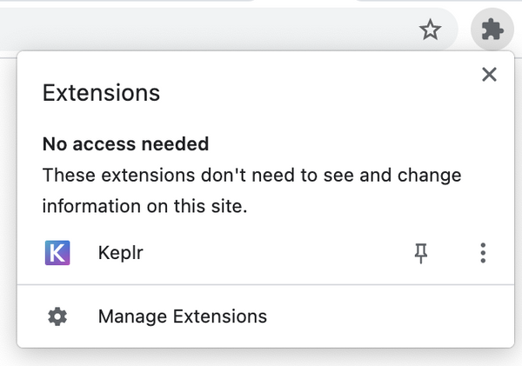



When you own ATOM with Keplr, **you are in charge**. There is no one you can call if *you forget your password/seed phrase or you send tokens to the wrong address*.   
  
Keplr is a non-custodial wallet.

With the Keplr extension installed and the previous warning in mind, create a new account. Click your Keplr extension and the following page should open:

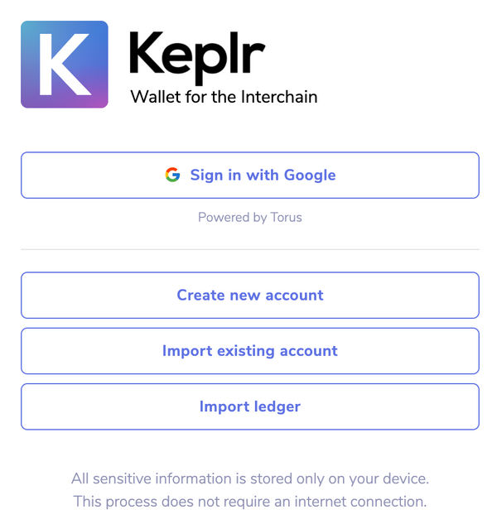

Click *Create new account*. A new page offers you a mnemonic (a secret list of words) and asks you for a password. Because **you are in charge**, it is important to understand the following points:

* Whoever knows the **mnemonic seed** has access to **all** the assets in the wallet as easily as you do. This means that:
  + Nobody else should be looking at your screen right now. If that is not the case, click *Back*.
  + You should only ever share your mnemonic seed with parties you would also give access to your bank account. **Do not** share it with an exchange, a proof-of-stake validator, another blockchain service, or "someone from the Interchain" on the phone - these are *not* trusted partners.
  + You should save the mnemonic seed in a safe place, so that you can import it back into this or another wallet at a later date. **Make sure** you write it down somewhere safe.
* Keplr saves your seed on disk but in an encrypted form.
* Keplr asks you for the **encryption password**, which is used to encrypt your mnemonic on your computer. For the password, keep in mind:
  + It should be a strong password.
  + You should also save it securely.
  + Keplr will ask you for it every time you open the wallet and for important actions.
* If your computer or the encrypted mnemonic seed file is stolen, your wallet assets are only as protected as your password is strong.

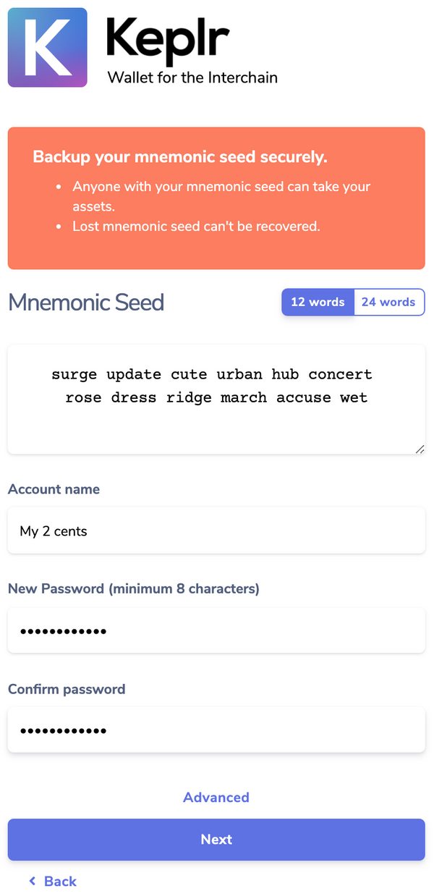

When you are ready, click *Next*.

If you saved your seed, you should be able to complete the next step: click on each word in the correct order.

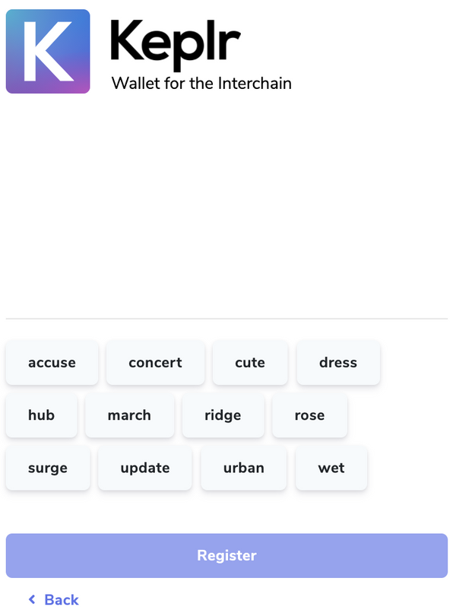

When done, the *Register* button should become active:

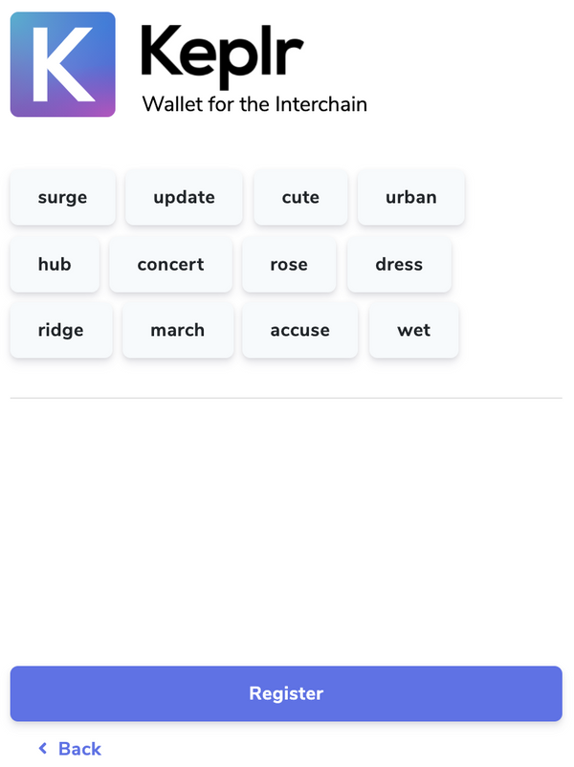

Click *Register*. Your Keplr wallet is now fully created:

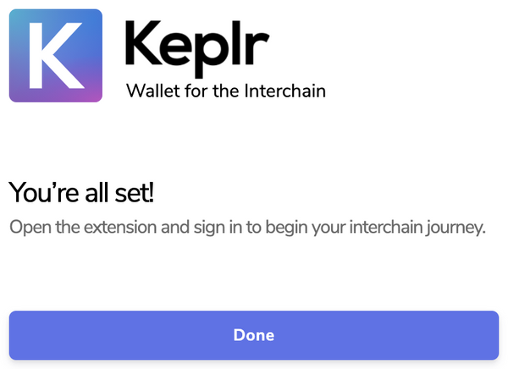

Click the extension icon again. It shows your first public address in the form cosmos1..., and that you hold zero ATOM.

Click the drop-down menu labeled *Cosmos* at the top of the screen to see how many assets from other supported networks you have:

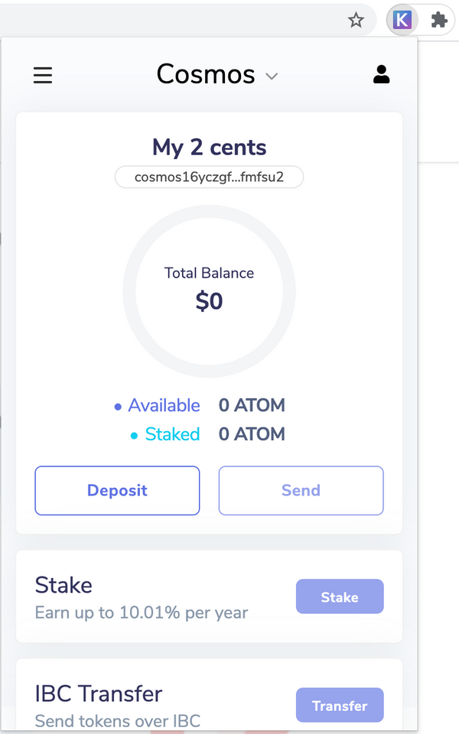



A note on your **address**: As with a street address, it is OK for others to know it, as it allows others to send you ATOM or other assets.

You can also open the [Keplr dashboard page (opens new window)↗](https://wallet.keplr.app/#/dashboard), which interfaces with the extension. Note that the dashboard at this address is a web page loaded from a website and, as such, is **not** a trusted partner. It will never ask you for your mnemonic or your password.



Be sure to save your mnemonic and password safely before you put any valuables in your wallet.

[#Copy link](https://ida.interchain.io/academy/1-what-is-cosmos/3-atom-staking.html#purchase-one-atom) Purchase one ATOM

How you purchase ATOM depends on your preference, but you need to use your trusted exchange to purchase ATOM. You can buy any amount you wish, although it is recommended to get at least 0.3 ATOM so your funds are not consumed in transaction fees before the end of this exercise.

For the purpose of this section we assume you buy one ATOM.



As you can see in the [Get ATOM and stake page (opens new window)↗](https://cosmos.network/learn/get-atom) from the Interchain, there is a [list of exchanges (opens new window)↗](https://messari.io/asset/cosmos/markets) that are known by the Interchain for offering ATOM tokens.

When you are done, your account on the exchange should show that you *own* one ATOM:



However, you do not yet own it as you would if the token were in your Keplr wallet. The exchange still owns the token but assures you that they will send it to you when asked. The exchange acts like a custodial wallet.

[#Copy link](https://ida.interchain.io/academy/1-what-is-cosmos/3-atom-staking.html#withdraw-your-atom) Withdraw your ATOM

Your exchange has a withdrawal function that allows you to send your ATOM anywhere, including to your Keplr wallet. You must set this up.

You need your wallet address. Since it is very long, you should avoid typing it by hand and instead copy it to the clipboard by clicking it in Keplr:

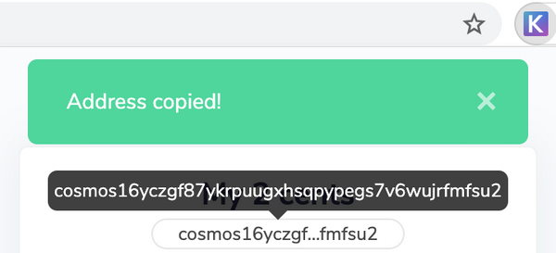

Now go back to your exchange and paste this address where asked. **Confirm that it looks identical to the original you copied**, and proceed with the confirmation the exchange requires from you:

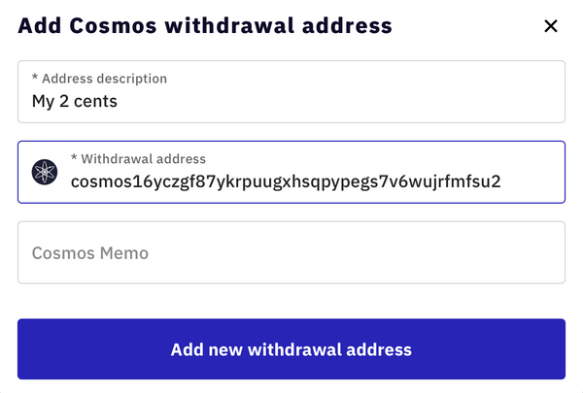

When this is set, you ask the exchange to withdraw properly. Take note of the transaction fee of the exchange. It is much higher than a realistic transaction fee would have been, had you done the transaction yourself within your wallet:

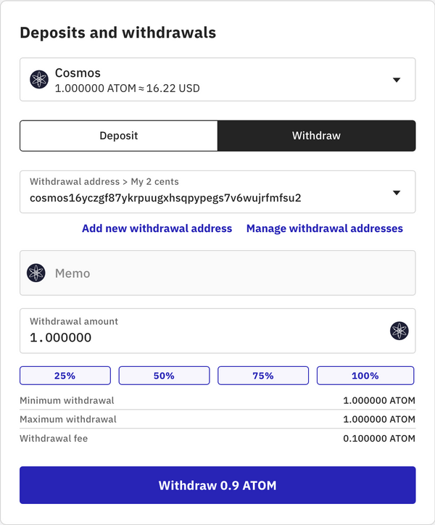

If all went well, you should see your new asset in Keplr after a few minutes:

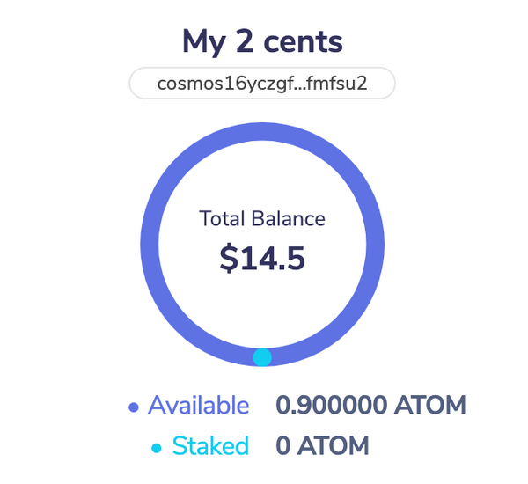

Congratulations! You now own slightly less than one ATOM. Remember that **you** are really in charge, so check again that your mnemonic and password are saved properly.



You can also look at your address using a public explorer, like [mintscan.io (opens new window)↗](https://mintscan.io/).

You can see the same if you open the [wallet dashboard page (opens new window)↗](https://wallet.keplr.app/#/dashboard). On this wallet page you can see a small link icon that leads you to your address page:

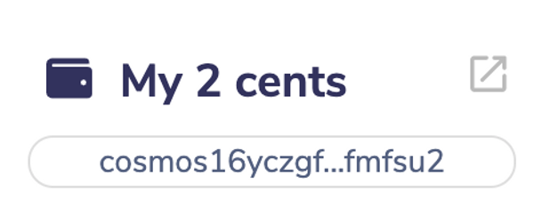

There you can see the transaction that originated from the exchange's wallet:

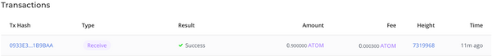

[#Copy link](https://ida.interchain.io/academy/1-what-is-cosmos/3-atom-staking.html#stake-your-atom) Stake your ATOM

Your 0.9 ATOM is now available and waiting in your wallet. It will stay there and remain 0.9 ATOM forever unless you use it for something.

*What about participating in the security of the Cosmos Hub blockchain?*

You can do this by delegating some of your ATOM as stake to a network validator. A validator consists of one or more cooperating computers that participate in the consensus by creating blocks. In exchange for this service, validators receive block rewards and share the rewards with their delegators, minus their commission. Your modest delegated stake could award you a modest share of a validator's rewards.



When considering staking, keep the following factors in mind:

* Unlike a centralized exchange that holds your assets in a custodial wallet, when you delegate your ATOM **you remain in charge of your ATOM**. The validator does not have access to your assets. Think of your stake as a weighted vote of confidence.
* There is a non-zero risk that the validator you chose behaves incorrectly or even maliciously, which exposes the faulty validator *and you* to **protocol penalties**.
* When you delegate ATOM to a validator, it becomes **locked**. You cannot use it for anything else, and **there is a time commitment**. Should you decide to un-delegate your stake, you will have to wait **three weeks** to regain access to your delegated stake.

Now find a validator and delegate your ATOM to it. Click the *Stake* button in Keplr. You are presented with a list of validators:

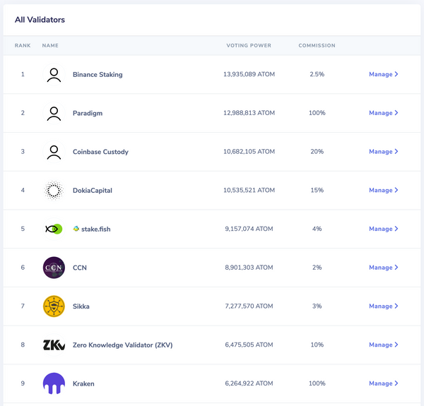

You can immediately discard any validators that keep 100% of the rewards for themselves, as they work for custodial wallets kept on behalf of their customers. Pick a validator that you like, click *Manage*, and a link will direct you to more information on this validator. You can see more information on each validator on [Mintscan's validator list for the Interchain (opens new window)↗](https://www.mintscan.io/cosmos/validators). Pay attention to the uptime, as a missed block would cost you penalties.

A validator can have small or large voting power. The larger the voting power, the more often the validator is tasked with issuing a block. Voting power is closely linked to the reward amount you can expect:



**Validator has large voting power**

If your chosen validator has large voting power, your rewards come frequently (for example, every minute) but in small numbers.



**Validator has small voting power**

If your chosen validator has small voting power, your rewards come infrequently (for example, every hour) but in large numbers.

Over the long run, you should receive the same amount in rewards regardless of whether your chosen validator has large or small voting power. What matters more is the size of your stake.

If you like the validator's information, click *Delegate* and add the sum you want to delegate. Do not delegate all that you own, because you need a fraction of ATOM to send the transaction, plus further ATOM in the future to either un-delegate or claim your rewards.

Pick 0.8 ATOM and click *Delegate* again:

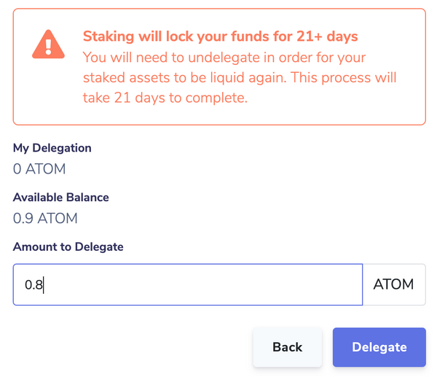

This delegation is an important action. It is the first action you take with your private key. Every time an application asks Keplr to do an important action, Keplr will ask you to confirm it:

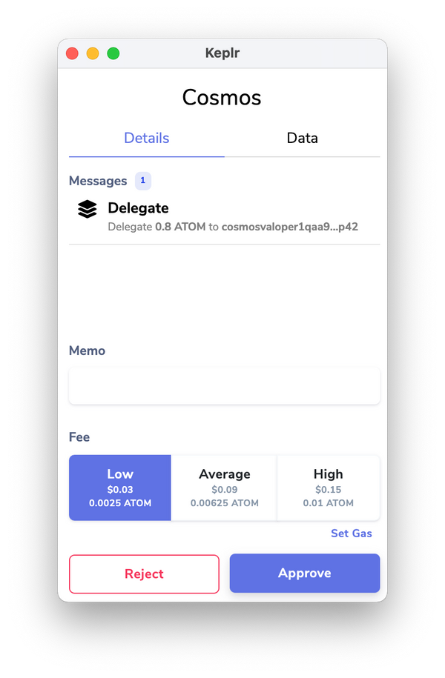

You do not need this delegate transaction to be confirmed quickly, so choose the low end of transaction fees and click *Approve*. The transaction should not take longer than a couple of minutes to be confirmed.

When it is confirmed, your **pending staking rewards** start to accrue. Their increase will not be fast because you delegated only 0.8 ATOM, and they only accrue when your chosen validator issues a block. After perhaps 20 minutes, you should see something similar to this:

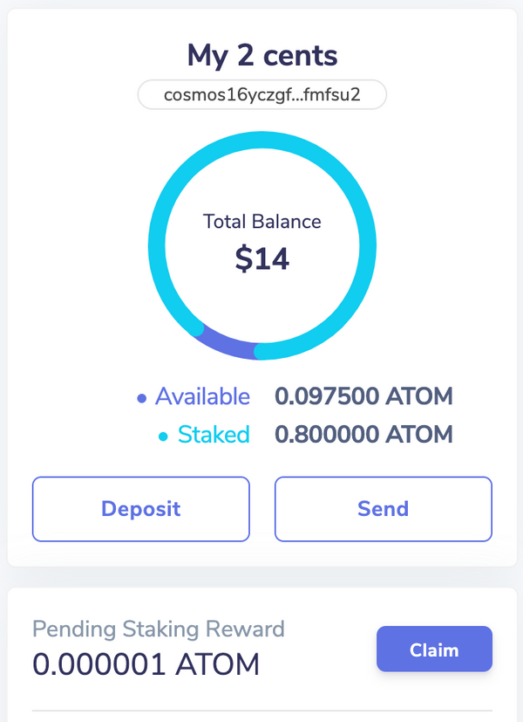

Your rewards are said to be "pending" because you need to claim them before they are yours. The claim transaction incurs fees, so it is best to wait until your rewards exceed the transaction fees before submitting any claim transaction. With only 0.8 ATOM staked you will need to wait about 10 days to accrue something worth the claim transaction.

[#Copy link](https://ida.interchain.io/academy/1-what-is-cosmos/3-atom-staking.html#claim-your-atom) Claim your ATOM

You did it! You waited 10 days, and have accrued rewards:

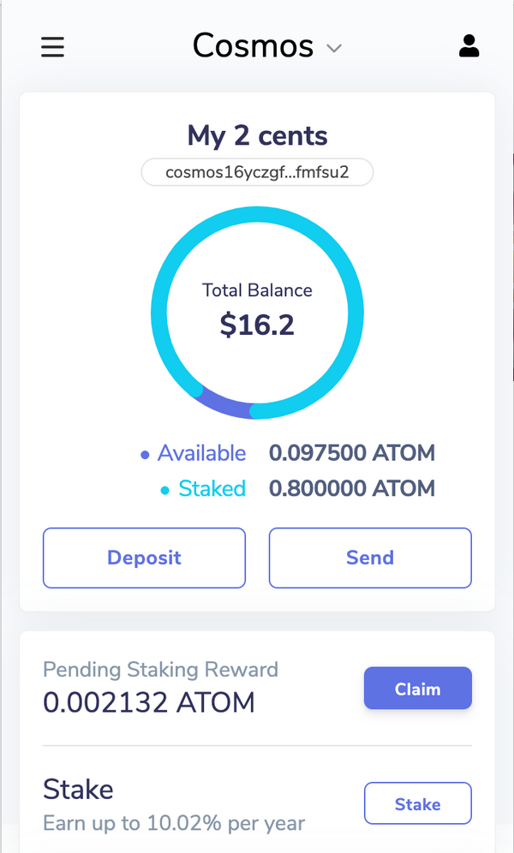

This is enough to cover the claim transaction. Go ahead and claim it. Again, choose the low fee option to reduce loses against this small reward sum:

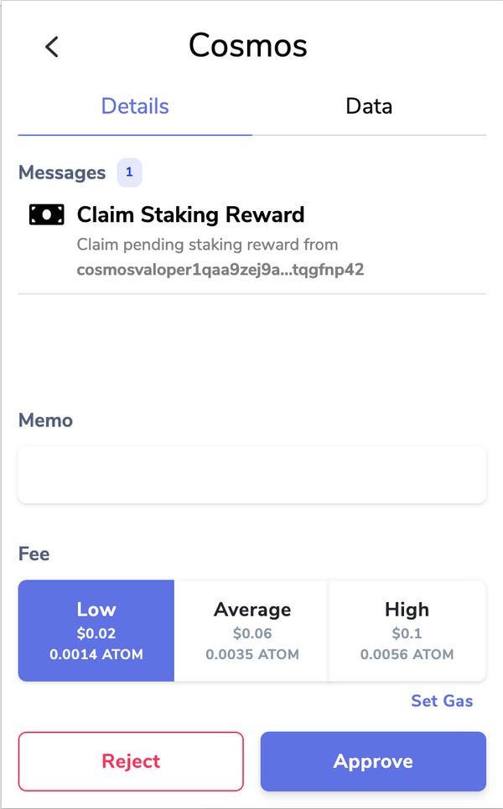

Your rewards are added straight to your wallet:

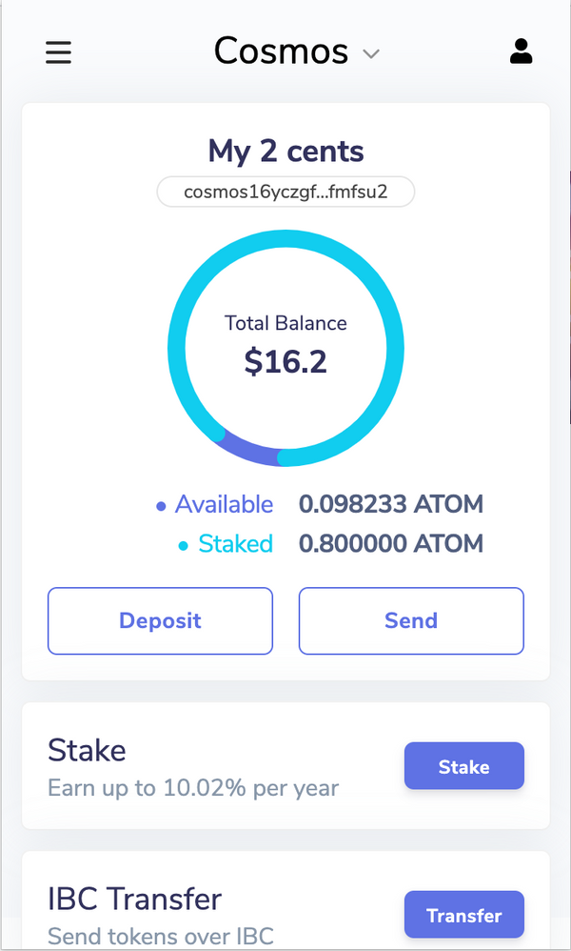

If you want to re-stake this amount and benefit from the compound effect, go ahead, but make sure you do not lose too much in transaction costs.

This completes the exercise: you are set up to participate in the Cosmos Hub network, and even contribute to its security. Your stake will work for you as you continue your Interchain training journey.

synopsis

To summarize, this section has explored:

* How to safely install and configure a Keplr wallet and transfer ATOM into it.
* How to stake ATOM on a validator, thereby participating in the security of the blockchain and potentially increasing your wealth by accruing staking rewards.

previous

[](https://ida.interchain.io/academy/1-what-is-cosmos/2-cosmos-ecosystem.html)

**[The Interchain Ecosystem](https://ida.interchain.io/academy/1-what-is-cosmos/2-cosmos-ecosystem.html)**

up next

**[A Blockchain App Architecture](https://ida.interchain.io/academy/2-cosmos-concepts/1-architecture.html)**

[[](https://ida.interchain.io/academy/2-cosmos-concepts/1-architecture.html)](https://ida.interchain.io/academy/2-cosmos-concepts/1-architecture.html)

Rate this Page

icon smile

icon meh

icon frown

Would you like to add a message?

Submit

Thank you for your Feedback!

[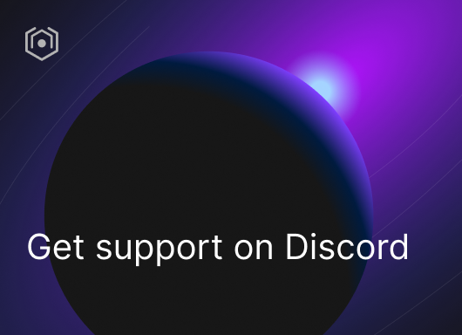](https://ida.interchain.io/ida-course/discord-info.html)

On this page

[Setting up Keplr](https://ida.interchain.io/academy/1-what-is-cosmos/3-atom-staking.html#setting-up-keplr)

[Purchase one ATOM](https://ida.interchain.io/academy/1-what-is-cosmos/3-atom-staking.html#purchase-one-atom)

[Withdraw your ATOM](https://ida.interchain.io/academy/1-what-is-cosmos/3-atom-staking.html#withdraw-your-atom)

[Stake your ATOM](https://ida.interchain.io/academy/1-what-is-cosmos/3-atom-staking.html#stake-your-atom)

[Claim your ATOM](https://ida.interchain.io/academy/1-what-is-cosmos/3-atom-staking.html#claim-your-atom)

#### **Get Cosmos updates**

Unsubscribe at any time. [Privacy Policy↗](https://v1.cosmos.network/privacy)

     Next

Documentation

[Cosmos SDK](https://docs.cosmos.network/)[Cosmos Hub](https://hub.cosmos.network/)[CometBFT](https://docs.cometbft.com/)[IBC Protocol](https://ibc.cosmos.network/)

Community

[Interchain blog](https://blog.cosmos.network/)[Forum](https://forum.cosmos.network/)[Discord](https://discord.gg/cosmosnetwork)

Contributing

[Source code on GitHub](https://github.com/cosmos/sdk-tutorials)

[](https://ida.interchain.io/)

[Interchain Developer Academy](https://ida.interchain.io/)

**[](https://blog.cosmos.network/)[](https://twitter.com/cosmos)[](https://discord.gg/cosmosnetwork)[](https://www.linkedin.com/company/interchain-foundation/about/)[](https://reddit.com/r/cosmosnetwork)[](https://t.me/cosmosproject)[](https://www.youtube.com/c/CosmosProject)**



Dark mode

† This website is maintained by the Interchain Foundation (ICF). The contents and opinions of this website are those of the ICF. The ICF provides links to cryptocurrency exchanges as a service to the public. The ICF does not warrant that the information provided by these websites is correct, complete, and up-to-date. The ICF is not responsible for their content and expressly rejects any liability for damages of any kind resulting from the use, reference to, or reliance on any information contained within these websites.

Cosmos is a registered trademark of the [Interchain Foundation.](https://interchain.io/)[Privacy](https://v1.cosmos.network/privacy)